Write SQL queries that:
- Create a unified, standardised table combining AWS + GCP spend:
o Include cloud_provider column
o Ensure consistent field names & data types

CREATE TABLE unified_cloud_spend AS
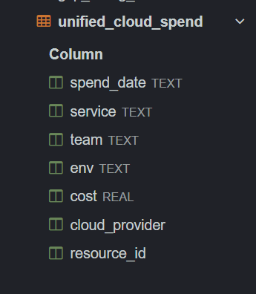
SELECT
date as spend_date,
service,
team,
env,
cost_usd as cost,
'AWS' as cloud_provider,
account_id as resource_id
FROM aws_line_items_12mo
UNION ALL
SELECT
date as spend_date,
service,
team,
env,
cost_usd as cost,
'GCP' as cloud_provider,
project_id as resource_id
FROM gcp_billing_12mo;

- Compute monthly spend by cloud provider

SELECT
strftime('%Y-%m', spend_date) as billing_month,
cloud_provider,
SUM(cost) as total_spend
FROM unified_cloud_spend
GROUP BY 1, 2
ORDER BY 1, 2;

O/P:
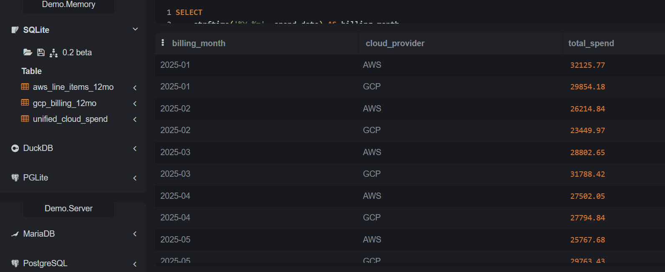

- Compute monthly spend by team & environment

SELECT
strftime('%Y-%m', spend_date) as billing_month,
team,
env,
SUM(cost) as total_spend
FROM unified_cloud_spend
GROUP BY 1, 2, 3
ORDER BY 1 DESC, total_spend DESC;

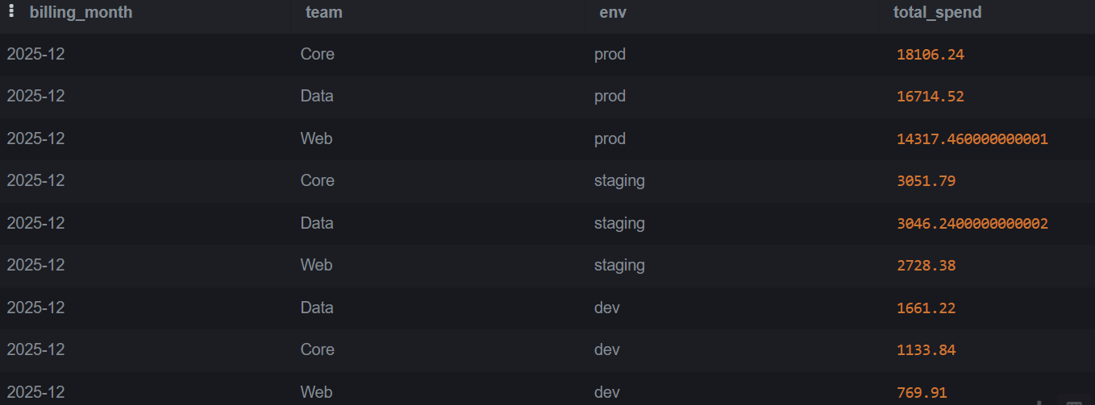
O/P:

- Identify the top 5 most expensive services across both clouds

SELECT
service,
cloud_provider,
SUM(cost) as total_spend
FROM unified_cloud_spend
GROUP BY 1, 2
ORDER BY total_spend DESC
LIMIT 5;

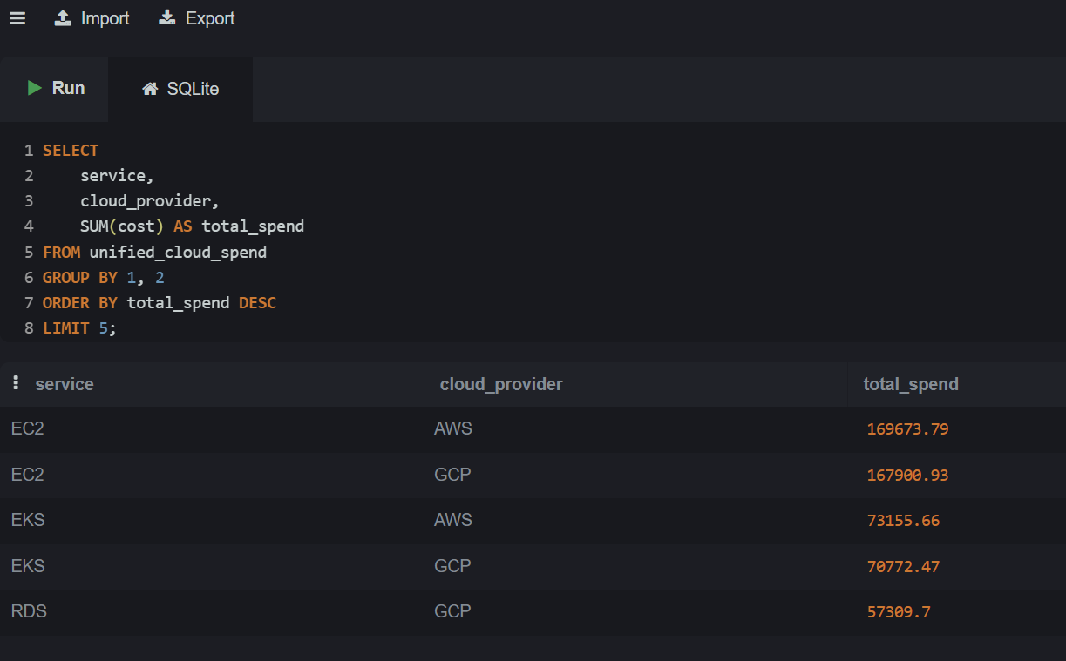
O/P:

